National Respiratory Audit Programme (NRAP)
Pulmonary rehabilitation (PR): Approval to collect patient identifiable information without consent

Dear Caldicott Guardian,
The National Respiratory Audit Programme (NRAP) launched on 1 June 2023, continuing the delivery of asthma and COPD audits of primary care, secondary care, and pulmonary rehabilitation services as previously conducted under the National Asthma and COPD Audit Programme (NACAP).

Collection of patient identifiable information and patient consent:
The PR audit collects patient identifiable information (NHS number, date of birth, postcode data to enable linkage with data from Hospital Episode Statistics (HES), Office for National Statistics (ONS) and Patient Episode Database for Wales, and report on patient outcomes). Sensitive information such as ethnicity and mental health status is also collected.

Section 251 approval:
This audit has Section 251 approval from the Health Research Authority Confidential Advisory Group (CAG). The CAG reference number is 23/CAG/0167.

Next steps for Caldicott Guardians:
Services that provide pulmonary rehabilitation (PR) to patients will register to participate in the PR audit. For their participation in this audit to fall within NHS information governance rules, we require your confirmation that all legal requirements for receiving and handling patient data (including identifiable and sensitive data) have been considered and will be complied with by your service.
- Please complete the form below and send it back to the NRAP team to confirm that your service has approval to participate in this PR audit.
- Once Caldicott Guardian approval has been received, your service will be granted access to the online audit data collection tool.

Access to this tool will not be granted, until receipt of this approval.

Submitting Caldicott Guardian approval:
Please provide approval for your service. Approval must be given by completing the form below and submitting it to praudit@rcp.ac.uk.

Further information about the PR audit and NRAP:
Further information about the PR audit and wider NRAP programme can be found here.
If you have any queries about the PR audit, please contact the audit team at praudit@rcp.ac.uk or
020 3075 1526.

Thank you in advance for your support.

Yours faithfully,

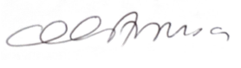
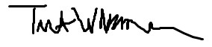

Professor Tom Wilkinson Lara Amusan
National Respiratory Audit Programme National Respiratory Audit Programme
Programme Senior Clinical Lead Programme Manager

Caldicott Guardian approval form

We would be grateful if you could sign this form to confirm that you are happy that all legal requirements for receiving and handling patient data (including identifiable and sensitive data) have been considered and will be complied with by services within your service, and you are happy to support their participation in this NRAP PR workstream.

Trust/Health Board
Service(s)
Name of Caldicott Guardian
Signature | 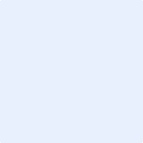
Date

